**Process of adding Rshiny Graphs in Word Press Website**

For adding Rshiny graph in word press website, we have to make a website in wordpress and one graph in Rstudio. In Rstudio we will have to do some coding for graph. After that we will have to run that coding to see the output.

After getting the graph in output, we will make an account in Rstudio.

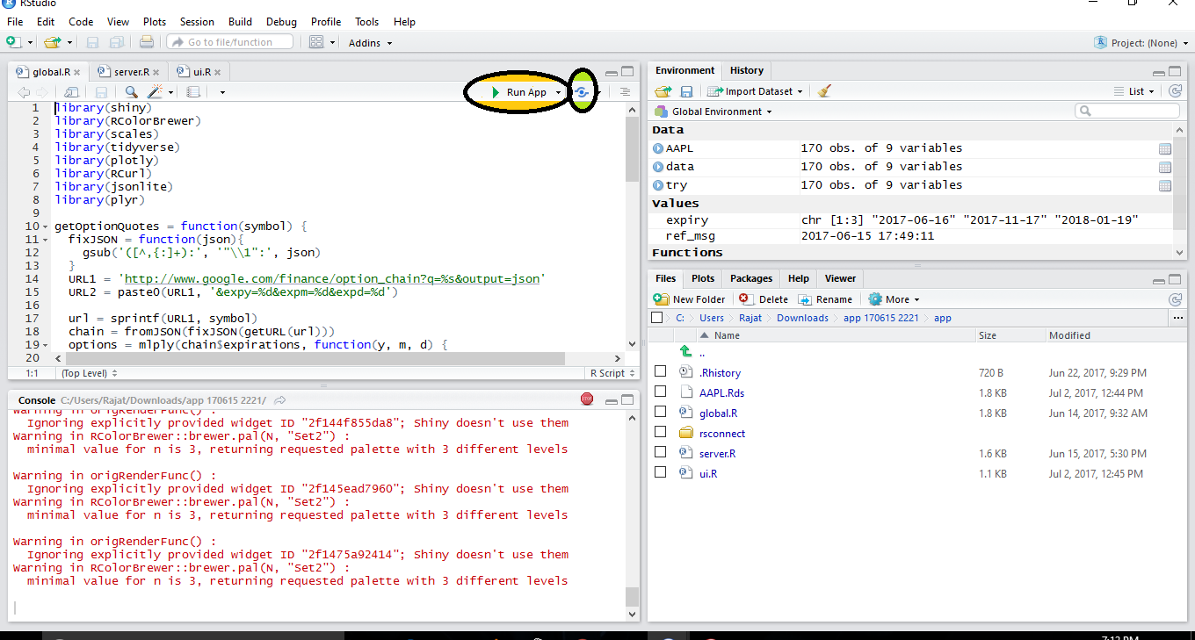

Output of coding

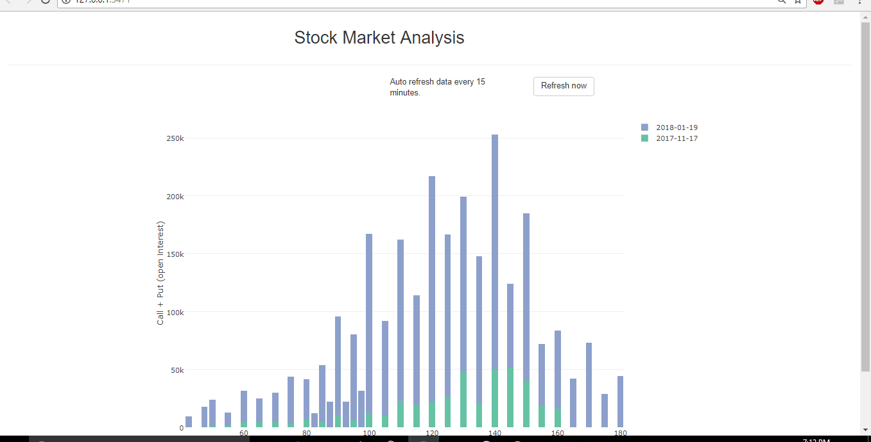

We will have to select add new account for making account.

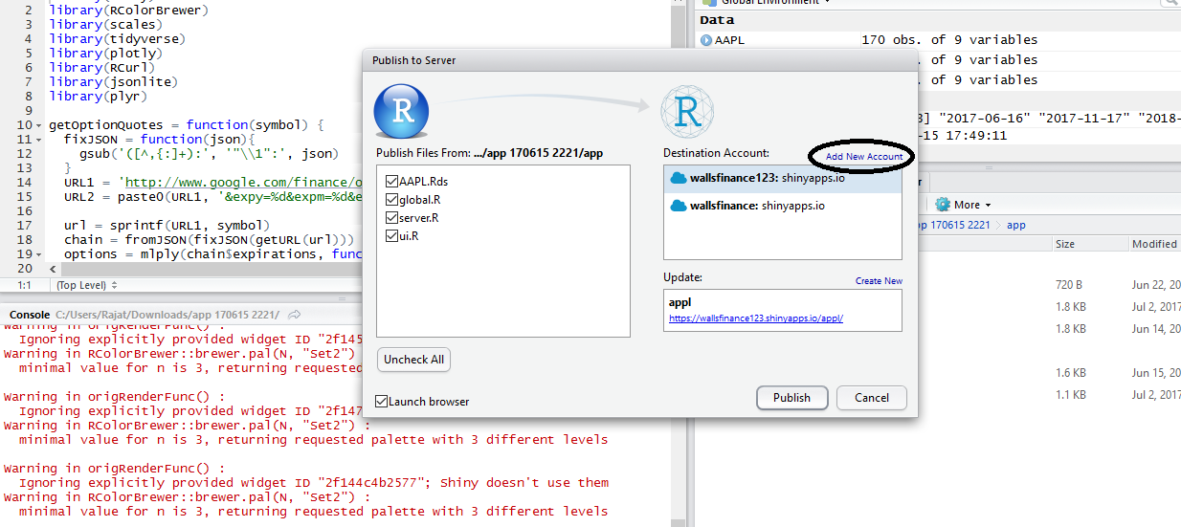

We will also make an account in shinyapps.io. This is a website which will act like a cloud for graph.

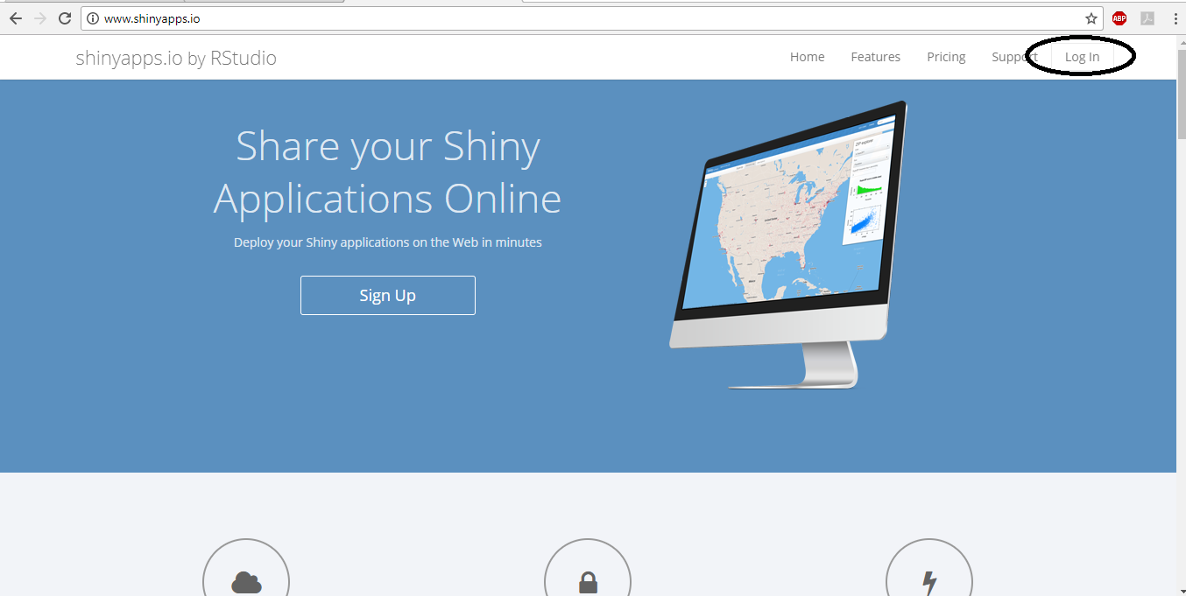

We can sign up with mail.

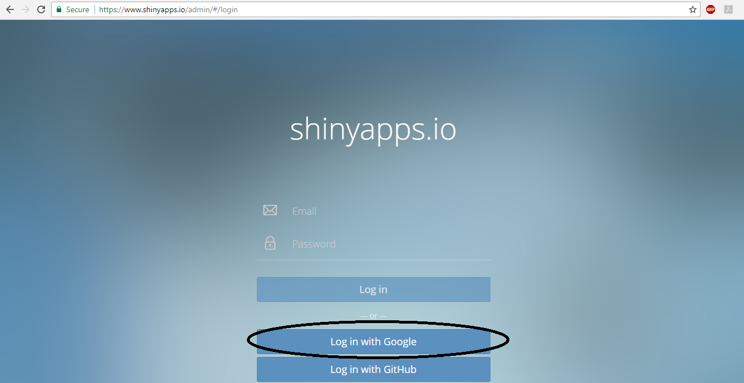

After creating account in shinyapps, we will click on tokens, then show and at last, show secret. We will do this to find out the secret code of our account.

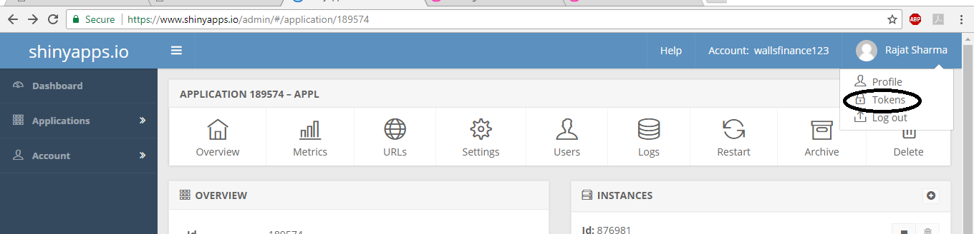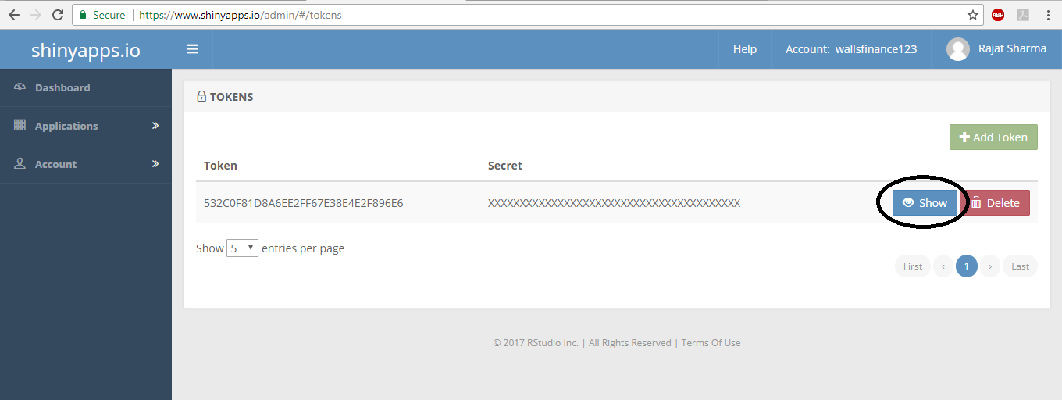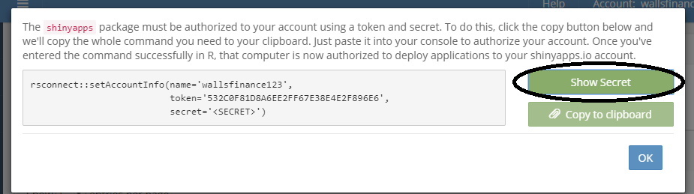

Then we will copy that code and we will paste that code in our Rstudio account under shinyapps.io. This will connect our Rstudio and shinyapps account together.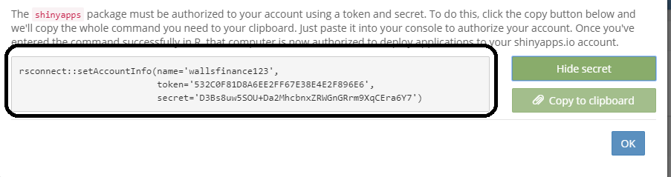

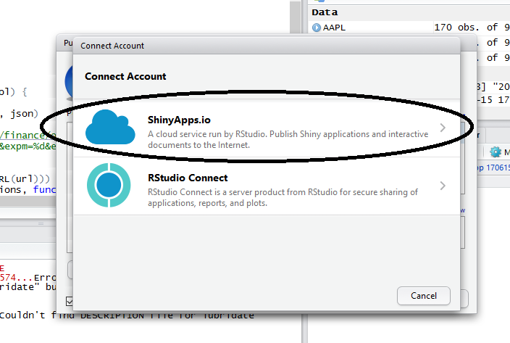

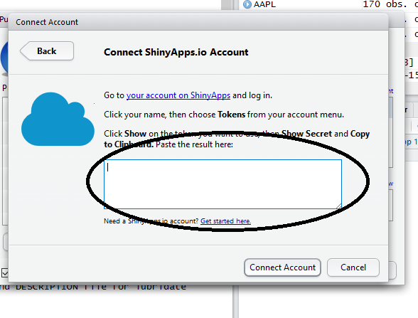

After connecting accounts, the graph of Rstudio will automatically gets uploaded on shiny app account under new name and id.

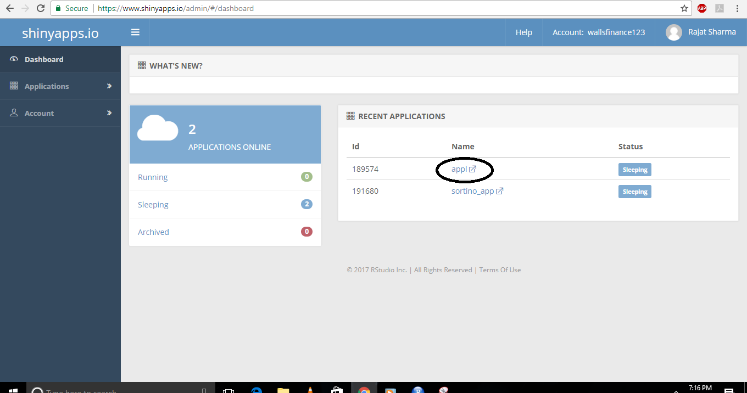

When we will open that app, we will find a URL for graph. We will have to copy that URL.

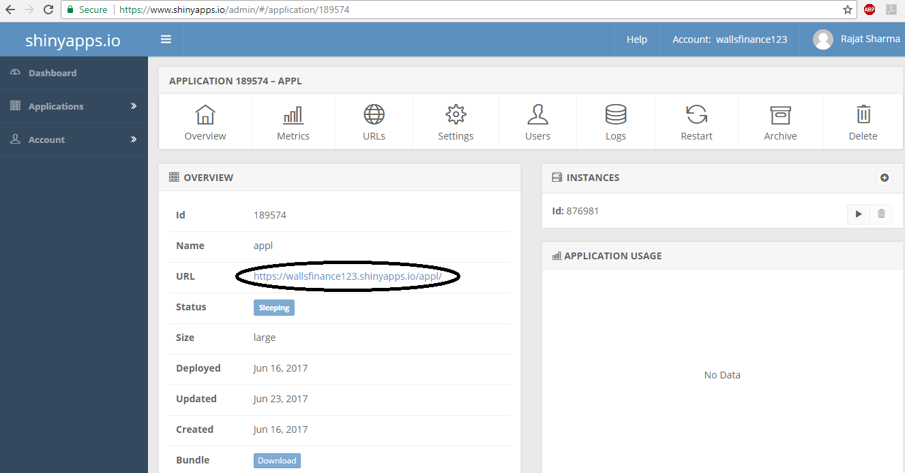

Then we will have to open the admin page in wordpress website. We will copy that URL in between iframe code in our page.

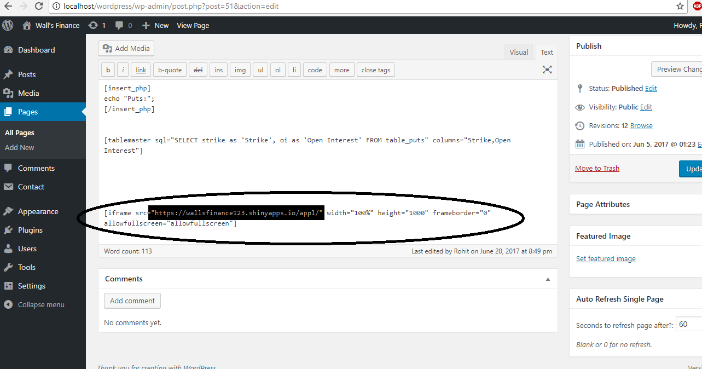

Then that Rstudio graph will be shown in Word Press Website..

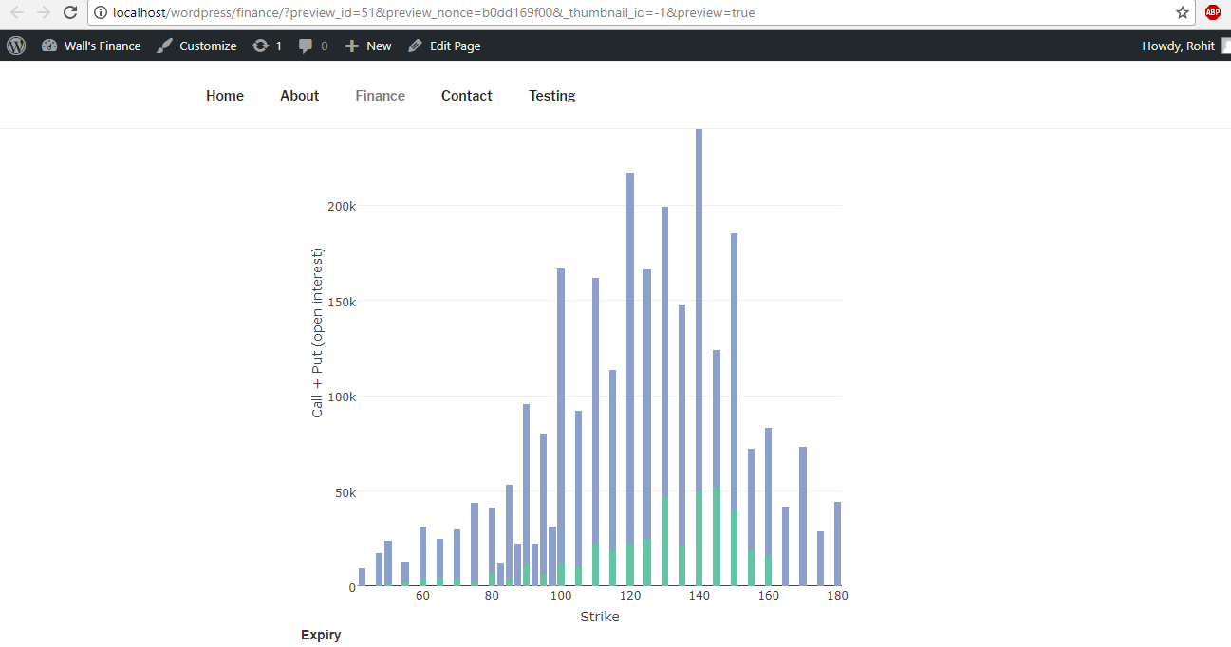

This is the process of adding Rshiny Graph in Word Press Website